Clinical Feedback meeting notes by Goutam Reddy (greddy@abiogenix.com)

3/30/20 meeting @ Stanford Health (they run the drive-through swabbings)

Interviewed: Dr. Linda Barman, Thanh Khong PAC, Another Physician

Summary of Design Notes:

1. felt no difference between Frozen vs. Room Temperature swabs
2. Liked spiral design with recommended modifications from other designs:
   1. spiral head w/ rounded tip (Barman design)
   2. move neck-body interface down (to position of spring designs)
   3. thicken breakpoint (okay to bend and twist to break off into tube)
   4. move breakpoint down to 100mm
   5. head of tip is fine, could be a little rounder
   6. tip flimsiness: make sure doesn’t break when bent backwards (pushed against obstruction)

Swab Note:

They liked the 100mm break-off. Once again WARNED that the 80mm break-off would be going into the nose of the patient, or would not reach nasopharynx. <see video>

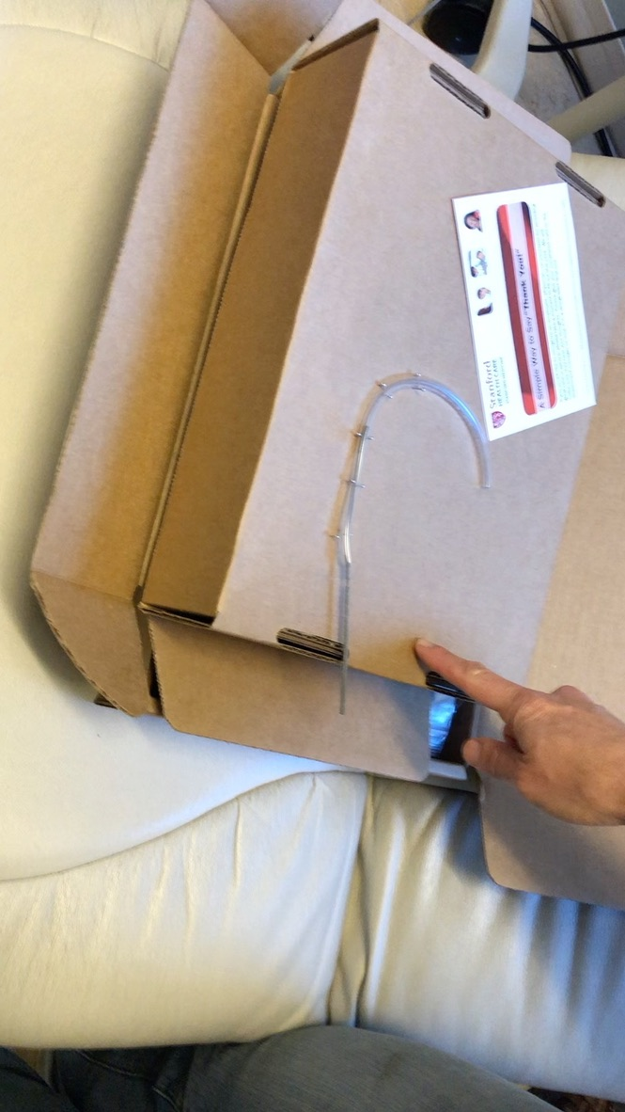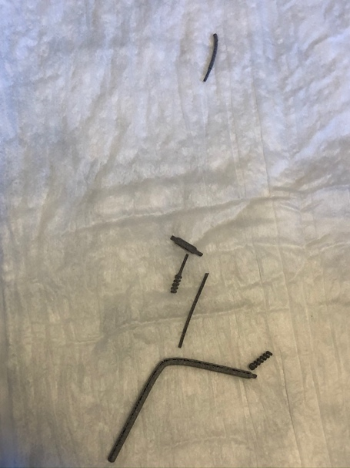

General Notes:

1. They liked the tube testing: said to test with more kinks/bumps to ensure simulation of blockages and constrictions.
2. They tested by pushing the swab into the palm and backside of their hands to test flexibility
3. They made a constriction of a hole in their hand and tried pushing into the constriction
4. They clenched a fist and twisted in their hand
5. They also twisted and pulled and bent swab to test material strength
6. All colleagues suggested a slight curve to the neck

Test 21) HP Spring 80mm (mfg by HP in San Diego)

* autoclaved at 121 vs 134: no difference
* frozen vs room temperature: no difference

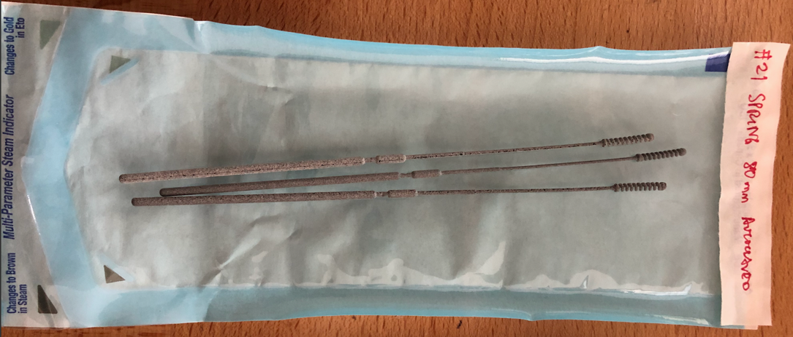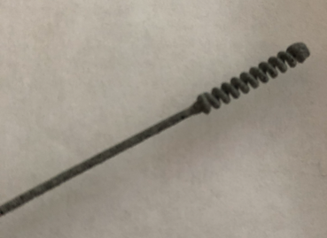

* Like head; end should be rounder (tip rounder)
* snapped neck and snapped head (too brittle, “more brittle”)
* make it stiff, but not brittle
* “will jam up” inside nose
* “too soft, jam up and not go”
* Spring is too floppy, “too floppy”
* Stiffen shaft a little
* Spring harder to get through

Test 22) HP Spring 100mm (mfg by HP in San Diego)

* autoclaved at 121 vs 134: no difference
* frozen vs room temperature: no difference

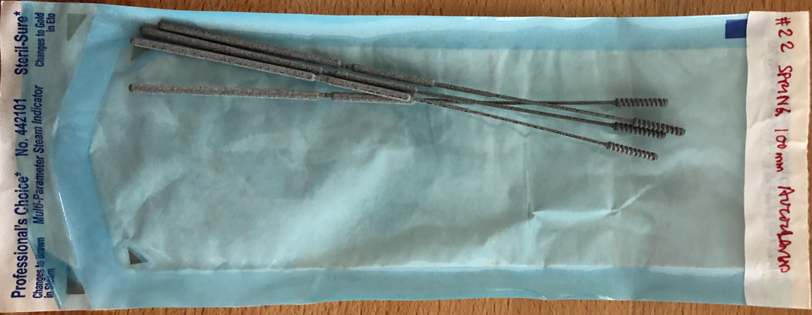

* spring way too wiggly; like spiral because it is stiffer
* spring too bendy
* neck too skinny -> make thicker
* want a little stiffer than spring, but not breakable like spiral
* like breakpoint placement

Test 23) Fathom Squares in PA12 (mfg by HP in San Diego)

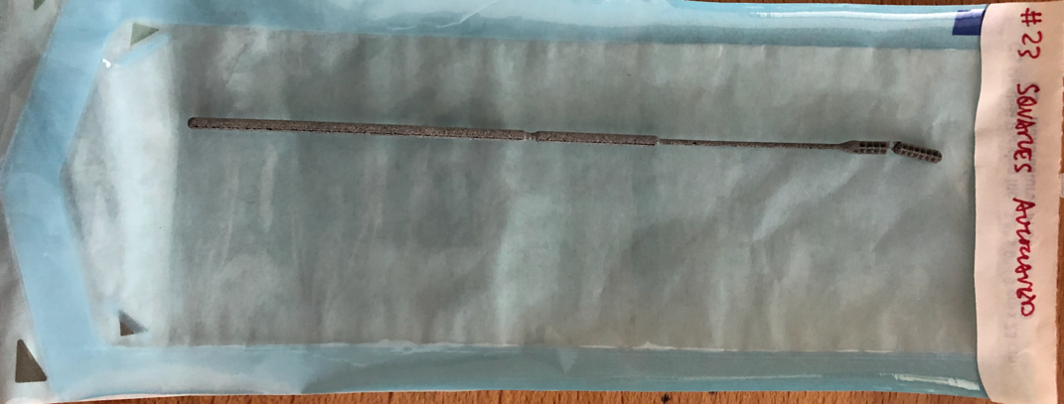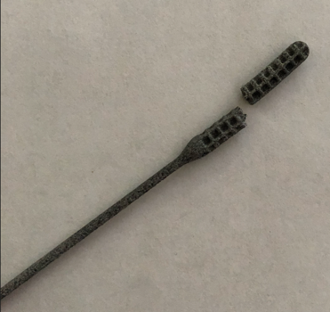

* not rounded enough
* stiffer than spring
* like thickness of neck
* make the breakpoints (for all) harder to break;
  + if you have to bend and twist, its no problem
* the cutdown is too thin

Test 24) Barman-Fathom Spiral in PA12 (mfg by HP in San Diego)

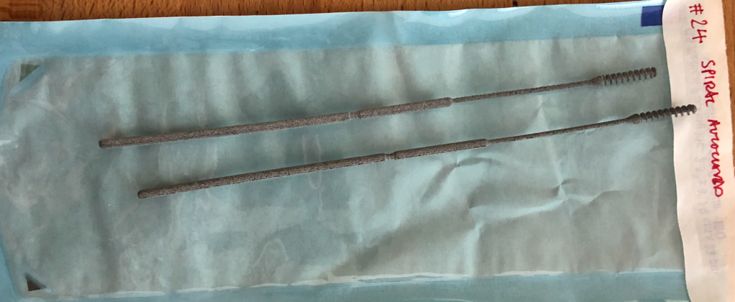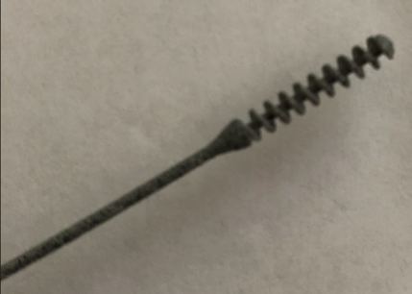

* like this head the best (not as stiff as squares, not as flimsy as springs)
* tip okay, but round out tip even more if you can
* neck not long enough = make longer
* broke neck by flexing
* breakpoint is too deep of a cut => make stronger
  + don’t’ want to snap off inside someone’s nose
* move breakpoint to 100mm design